

**Faculty Mentorship Leadership Program**

**Developmental Network Mapping Exercise**

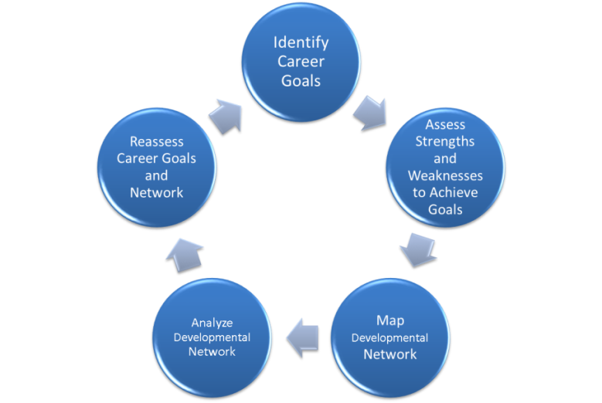Mentorship has been positively associated with career development and productivity. New models of mentorship have transitioned from the reliance on the dyadic (single mentor-mentee pair) and hierarchical (mentor is senior to mentee) framework to Developmental Networks, which emphasize the importance of relationships with people who help get the work done, help advance one’s career, and/or provide personal support. Developmental Networks may include traditional scholarly/research mentors, advisors, peer mentors, e-mentors, colleagues, juniors, mentees, family, and friends who provide access to knowledge, opportunities, and resources across institutions and cultures. The following steps will assist you in assessing your Developmental Network relative to your career goals.

Draw your Developmental Network using the table and diagram on page 3 and the example on page 2.

The table on page 3 helps you reflect and identify the people who assist you in 3 different ways

* **People who help you *get the job done***
* **People who help you *advance your career***
* **People who provide *personal support* for you**

And then list those people according to the closeness of the relationship you have with them.

People with whom you have more than one kind of relationship should be listed more than once (i.e. one person could be in two or three categories). We also want you to place them in the column that best describes the type of relationship you have with them. **Close** relationships are ones where there is a high degree of trust, liking and mutual commitment. **Distant** relationships are ones where you don’t know the person very well. **Moderate** relationships are in the middle, neither very close nor distant. The length of the line connecting each person back to you represents the relative closeness of your relationship. Superiors, peers, and juniors are distinguished by their placement around you.

Indicate by a star( ) those people whom you see as very well connected in your department, hospital or professional circle, including someone who “sponsors” you. A sponsor is a senior/influential person who actively advances your career trajectory. Write “mentor” or “mentee” inside the shape (square, triangle, or circle) of anyone you consider in that role.

***EXAMPLE* Developmental Network Table and Map**

**You: Junior Faculty**

**Types**

**Getting the Job Done:** People who help you fulfill your work requirements. They provide technical

advice, introductions, expertise, and/or resources.

**Close Relationship Moderate Relationship Distant Relationship**

|  |  |  |
| --- | --- | --- |
| NS, research assistant (Mentee) | JD, PI of grant ★ | CJ, administrative assistant |

**Advancing** **Your Career**: People who contribute to your professional development and career

advancement. They provide career guidance and direction, advice on funding, serve as “sponsors” to

help you get important assignments, and advocate on your behalf.

**Close Relationship Moderate Relationship Distant Relationship**

|  |  |  |
| --- | --- | --- |
| DR, senior faculty member in your division (Mentor) ★ | JD, PI of grant ★ | SW, Department Chair★ |
|  | AB, faculty at another institution |  |

**Getting Personal Support**: People you go to for your emotional well being and psychosocial support.

**Close Relationship Moderate Relationship Distant Relationship**

|  |  |  |
| --- | --- | --- |
| LG, spouse | FW, friend at work |  |
| DR, senior faculty member in your division (Mentor) ★ |  |  |

Intra-organizational 

Extra-organizational 

 well connected and/or “sponsors”

**ME**

**AB**

**CJ**

**JD**

★

**JD**

R

**FW**

**LG**

**Getting the Job Done**

**Advancing Your Career**

**Getting Personal Support**

**S**

**enior to me**

**Peers**

**Junior**

**to me**

**SW**

**DR**

**M**

**entor**

★

**DR**

**M**

**entor**

**NS**

**M**

**entee**

★

★

★

★

**Your Developmental Network Table and Map:**

**Types**

**Getting the Job Done:** People who help you fulfill your work requirements. They provide technical

advice, introductions, expertise, and/or resources.

**Close Relationship Moderate Relationship Distant Relationship**

|  |  |  |
| --- | --- | --- |
|  |  |  |
|  |  |  |

**Advancing** **Your Career**: People who contribute to your professional development and career

advancement. They provide career guidance and direction, advice on funding, serve as “sponsors” to

help you get important assignments, and advocate on your behalf.

**Close Relationship Moderate Relationship Distant Relationship**

|  |  |  |
| --- | --- | --- |
|  |  |  |
|  |  |  |

# Getting Personal Support: People you go to for your emotional well being and psychosocial support.

**Close Relationship Moderate Relationship Distant Relationship**

|  |  |  |
| --- | --- | --- |
|  |  |  |
|  |  |  |

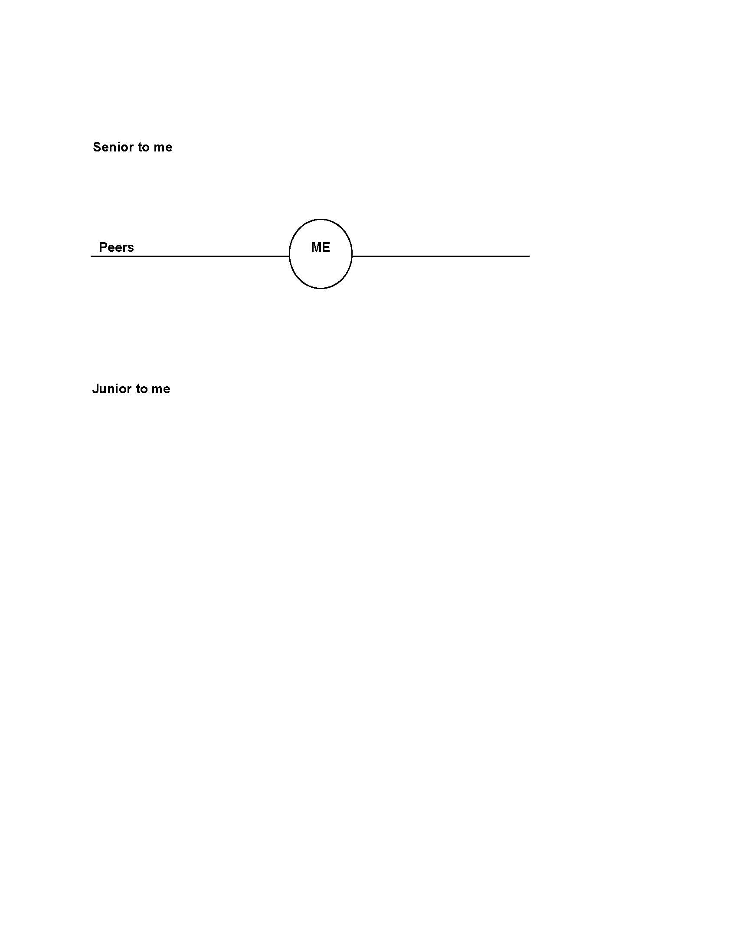

Intra-organizational 

Extra-organizational 

 well connected and/or “sponsors”

## 

**Analyzing and Maintaining Your Network**

|  |  |
| --- | --- |
| Networks vary in structure, content, and quality of relationships. Now that you have defined your Developmental Network, assess if it meets your goals. The questions below will help you determine the strengths and weaknesses of your network, and where you need to fill in gaps with new contacts. Be mindful of maintaining existing relationships, by staying in touch and “giving back” such as facilitating an introduction or sending an article of interest to the individual along with your comments. Professional conferences are another important way to reconnect with your existing developmental network and cultivate new connections. | |
| **Theme** | **Description** |
| ***Diversity*** | How similar or different are these individuals (in terms of gender, race, function, geography, organizations) to each other and to you? |
| ***Redundancy*** | How much overlap is there? Does one person serve every function? Do you have many people helping you get the work done but no one providing personal support? |
| ***Interconnectivity*** | How closed is the network in the sense that most of the people know each other? |
| ***Strength of Connection*** | What is the spread of people in terms of closeness and distance to you? |
| ***Balance*** | Is your network balanced or in danger of tipping? Do you have too many mentors and no mentees? Or for more senior faculty, do you have too many mentees but no longer have mentors? |
| ***Connections to Power/Influence*** | How many individuals would you characterize as influential in the department or hospital or field? |
| ***Size*** | How large or small is your network? Does the size fit your goals? Is the network a size that you can maintain? |

**CONCLUSIONS ABOUT YOUR NETWORK:**

Summarize the PATTERNS you see in your network; your STYLE of networking, and/or what you

might want to do differently in the future. Think about how to maintain the strengths of your

network, how to diversify, and how with time to increase the number of mentees and advisees.